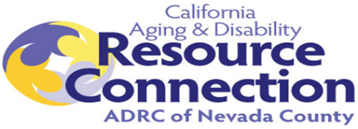

**Advisory Council for the**

**Nevada County Aging Disability Resource Connection (ADRC)**

Wednesday, December 4, 2024 - 12:30 to 1:30 p.m.

Videoconference/Teleconference

Join Zoom Meeting

<https://us02web.zoom.us/j/89633340477?pwd=M24zUFZhNTQ5WTVmUWtJQUYyMzd1dz09>

Meeting ID: 896 3334 0477

Passcode: 337406

**AGENDA**

**12:30 - 12:35 p.m.**

1. Welcome & Introductions – Kelly Carpenter, Chair, NC Adult Services
2. Review of Minutes from September Meeting – Attached

**12:35 – 12:45 p.m.**

1. Nevada County ADRC Updates:
   1. Nevada County Health Fair was on October 9th, 2024

**12:45 – 1:15 p.m.**

1. Master Plan on Aging and Disability Workgroup Updates
   1. Goal 1: Inclusion, Equity, and Social Participation
   2. Goal 2: Housing for All Ages and Stages
   3. Goal 3: Enhanced Caregiving Resources
   4. Goal 4: Progressive Health Care Access
   5. Goal 5: Expanded Transportation Options
   6. Goal 6: Effective Coordination, Communication & Education

**1:15 – 1:25 p.m.**

1. Community Partner Go-Around and Announcements

1:25 – 1:30 p.m.

1. Next ADRC Cross Training: February 5th, 12:30-1:30pm
2. Next ADRC Advisory Meeting: Wednesday, March 5th, 12:30-1:30pm